ARCHITECT REVIEW
SALDEV-1499 | Quote Line Type
Flow Deactivation
Flywire Partial sandbox | Read-only implementation and promotion-readiness assessment
Environment | FlywirePartial | Org 00DhG0000000jOX | Sandbox
Review date | 28 August 2026
Evidence | Live FlowDefinition/Flow/Apex read-back | unit-test results | coverage | source inspection
Decision | Changes Requested - not ready for promotion
Boundary | No code edits, deployment, activation, data changes, or Production changes

ARCHITECT DECISION
Do not promote yet. The legacy Flow is genuinely inactive and the before-save Apex direction removes its extra DML cycle, but the deployed trigger can skip existing rollup logic, formula-dependent fields are copied in the wrong sequence, and the tests do not prove the required field outcomes.

Acceptance outcome
# | Scope | Result | Evidence
1 | Flow deactivation | Pass | FlowDefinition.ActiveVersionId is null; latest v13 is Obsolete.
2 | Root-cause direction | Pass | Background fields moved to before-save memory assignment; no Flow self-update remains.
3 | Trigger regression safety | Fail | An after-update early return can bypass calculateAveragePrice().
4 | Functional sequencing | Fail | Quote Line Type is copied before price-change logic updates a field used by its formula.
5 | Automated proof | Partial | Eight tests pass, but SALDEV-1499 assertions do not verify the output fields or 200-line limits.

Incident mechanism and control path
The incident was raised after an after-save record-triggered Flow updated the same Quote Line that initiated the transaction. That second DML operation re-entered Quote Line automation and the transaction exhausted the 100-query synchronous limit. Moving simple assignments to a before-save trigger is the correct architectural direction because it modifies Trigger.new without a second update.
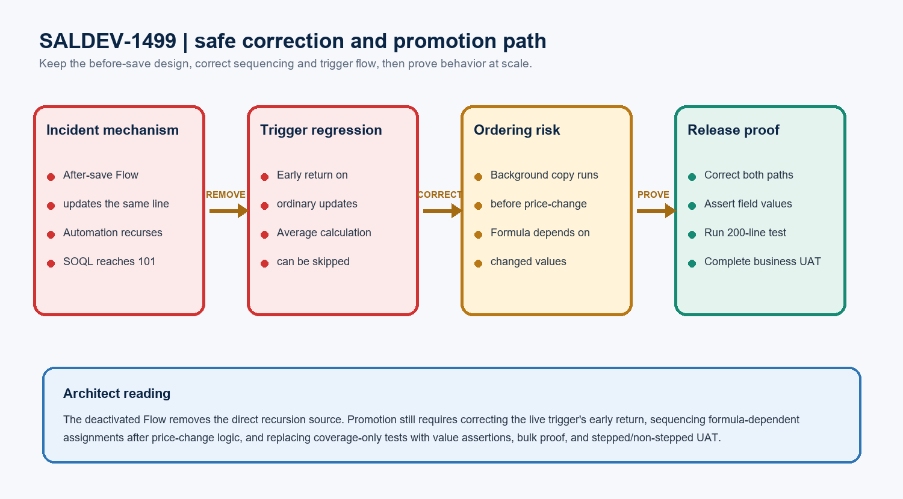
Figure 1. SALDEV-1499 safe correction and promotion path
DESIGN READING
Preserve the before-save, bulk-collected query pattern. Correct the control-flow and sequencing defects surgically, then prove field values and governor headroom. Do not reactivate the Flow as a workaround.

Current SALDEV-1499 implementation evidence

Flow and Apex state
Evidence area | Observed state | Result | Architect reading
Target org | FlywirePartial; sandbox; USA1148S | Pass | Verified against Organization Id 00DhG0000000jOXUAY.
Flow definition | ActiveVersionId = null | Pass | The Flow is genuinely deactivated.
Latest Flow version | v13; API 65; Obsolete | Pass | No active version remains.
QuoteLineTrigger | Active; API 67 | Partial | Before-save replacement exists, but after-update control flow can exit early.
Trigger handler | Active; API 67 | Partial | Bulk collection exists; background-field order and behavior require correction.
Failed Quote Line | a1zhG000000MBi7QAG not found | Partial | The exact incident record cannot be replayed or field-read back.

Automated test and coverage evidence
Evidence area | Observed state | Result | Architect reading
Latest focused run | 8 test methods passed | Pass | Latest results recorded 27 Aug 2026 around 21:15 UTC.
Trigger coverage | 23 covered / 10 uncovered | Partial | 69.7% aggregate coverage; uncovered branches include control paths.
Handler coverage | 245 covered / 24 uncovered | Pass | 91.1% aggregate coverage, but percentage does not prove behavior.
SALDEV-1499 assertions | Record existence / non-empty lists | Fail | Expected background, mismatch, fallback, and price-change values are not asserted.
Bulk governor proof | No 200-line limits test | Fail | The original SOQL-101 acceptance concern is not directly proven.

EVIDENCE BOUNDARY
The linked design document is not accessible to the connected Google account. Requirement alignment for fallback and adjusted-rate behavior therefore remains conditional until the team shares the document or records the decisions in Jira.

Detailed code-review findings
Priority | Finding | Why it matters | Required correction
P1 | After-update early return | When OLI synchronization is unnecessary, the trigger returns before calculateAveragePrice(). Ordinary updates can stop recalculating existing rollups. | Replace the trigger-level return with a guarded OLI-sync block so later after-save logic always reaches its own recursion guard.
P1 | Formula copy occurs too early | processBackgroundFields() copies Quote_Line_Type__c before handlePriceChangeOnAmendmentClones() updates Price_Change__c. The live formula depends on Price_Change__c and Group_Allow_Product_Ramping__c. | Compute price-change inputs first, then derive/copy Quote Line Type from final values, or calculate the classification explicitly in one method.
P1 | Tests do not assert outcomes | Passing tests can still leave Quote_Line_Type_background__c, Rate_Details_Changed__c, or Default_Rate_Details__c wrong. | Re-query records and assert exact true/false/text values for insert, update, ramp, renewal, amendment, cancellation, and blank cases.
P2 | Behavior exceeds the legacy Flow | Apex adds default-rate fallback and adjusted-rate override comparisons beyond the Flow's direct Rate_Details versus Default_Rate_Details check. | Confirm these rules in the design/Jira acceptance criteria and test each branch; otherwise narrow the implementation.
P2 | Local source is stale | The checkout still shows Flow v13 Active and an older after-only trigger. It does not match the live sandbox implementation. | Retrieve the exact live components into a focused review package before producing the promotion artifact or diff.

PROMOTION BLOCKER
Do not approve promotion until the trigger return and formula-ordering defects are corrected, explicit field-value assertions pass, and a bulk transaction demonstrates that the replacement stays below governor limits.

Functional equivalence and implementation boundary

Legacy-to-Apex behavior that must remain equivalent
Behavior | Legacy Flow | Replacement expectation
Quote Line Type background | Copy formula value after save when blank or different | Persist the classification calculated from the transaction's final price-change/ramping state.
Rate mismatch | Rate_Details__c != Default_Rate_Details__c | Match approved null/blank semantics and document any fallback/override expansion.
Record update | Explicit DML on the initiating record | Before-save memory assignment only; no self-DML.
Existing rollups | Separate trigger behavior | Continue calculateAveragePrice() on all intended insert/update/delete/undelete paths.

Focused correction scope
Component type | Focused scope | Required action
Quote Line trigger | Before-save call order | Run price-change classification before the background copy, or combine both deterministically.
Quote Line trigger | After-update OLI-sync branch | Remove the trigger-level early return and preserve subsequent rollup execution.
Trigger handler | processBackgroundFields | Define null/blank, fallback, adjusted-rate, and formula-copy behavior explicitly.
Apex tests | QuoteLineTriggerHandleTest | Assert exact outputs and prior rollup behavior; avoid pass-by-record-existence assertions.
Bulk proof | 200 mixed Quote Lines | Capture query/DML counts and verify all classifications, mismatch flags, and rollups.
Focused package | Trigger, handler, test, inactive Flow state | Retrieve current live metadata and validate only the reviewed components plus required dependencies.

Release sequence and production gate
Phase | Required evidence
Requirement confirmation | Share the design document or copy its approved decisions into Jira: formula timing, blank handling, fallback source, adjusted-rate rules, and stepped-up behavior.
Focused correction | Surgically correct trigger order/control flow and tests; keep the Flow deactivated and preserve unrelated CPQ automation.
Sandbox validation | Run the focused Apex class plus relevant Quote Line regression tests; record test-run ID, coverage, query/DML headroom, and field-level results.
Business UAT | Create stepped and non-stepped quotes; save/recalculate; confirm no SOQL-101 error and verify Quote Line Type, mismatch flags, and existing averages.
Promotion/read-back | After approval only: validate the production-target package, deploy, verify Flow ActiveVersionId remains null, read back Apex versions, and repeat smoke tests.

Validation evidence to capture
Evidence | Required detail
Automated test receipt | Test-run ID, named methods, pass/fail totals, runtime, and exact trigger/handler coverage.
Governor headroom | Queries and DML statements before/after the 200-line transaction, with no SOQL-101 exception.
Record-level read-back | Quote and Quote Line IDs plus expected/actual background type, mismatch flag, default rate details, and average fields.
Metadata state | FlowDefinition.ActiveVersionId, latest Flow status, Apex API/status/modified date, and reviewed package component count.

PRODUCTION GATE
This review covered FlywirePartial only. Production was not inventoried or changed. Re-retrieve current Production metadata and run focused check-only validation before any deployment decision.

UAT and approval gates
Test | Pass evidence
Ordinary Quote Line update | An update with no OLI-sync requirement still runs calculateAveragePrice() and preserves expected average placement.
Stepped-up renewal | A ramp-enabled renewal saves without error and background type equals the final Quote_Line_Type__c classification.
Amendment and cancellation | Price Change, Cancellation, and Cancellation Price Change outcomes match final quantity and price-change inputs.
Rate details equal/different | Equal values set Rate_Details_Changed__c false; approved mismatch/fallback/override cases set it true.
Blank and null handling | Blank formula/default/source/subscription cases produce documented values without stale background data or exceptions.
Bulk and limits | 200 mixed Quote Lines complete in one transaction with correct fields, rollups, query headroom, and no SOQL-101 error.
Non-stepped regression | Existing ordinary quoting and average-price behavior match the approved sandbox baseline.

Required approval gates
# | Required action | Owner | Evidence needed
1 | Confirm expanded rate-detail rules | Product Owner / Architect | Accessible design decision or Jira acceptance detail.
2 | Correct trigger control flow/order | Development Lead | Reviewed focused diff with no unrelated rewrite.
3 | Strengthen automated tests | Developer / QA | Exact field assertions, regression results, and 200-line limits evidence.
4 | Complete business UAT | CPQ Business Owner | Quote IDs, scenarios, expected/actual values, and no-error confirmation.
5 | Approve promotion | Architect / Release Manager | Check-only job ID, component/test counts, exclusions, and sign-offs.

Ready-to-paste architect response
STORY COMMENT
Architect review completed for SALDEV-1499 in FlywirePartial. Changes Requested. The Quote Line Type background Flow is correctly deactivated (ActiveVersionId is null; v13 is Obsolete), and the before-save Apex direction removes the Flow's self-update. However, the deployed after-update trigger can return before calculateAveragePrice(), and processBackgroundFields() copies the formula-backed Quote Line Type before price-change logic updates fields used by that formula. Eight focused tests pass, but the SALDEV-1499 tests do not assert the resulting background/rate-detail fields and there is no 200-line governor-limit proof. Correct the trigger control flow and sequencing, add exact field-value and bulk tests, share the detailed design decision, and complete stepped/non-stepped UAT before promotion. No code, metadata, activation, deployment, data, or Production changes were made during this review.

